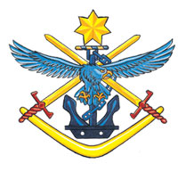
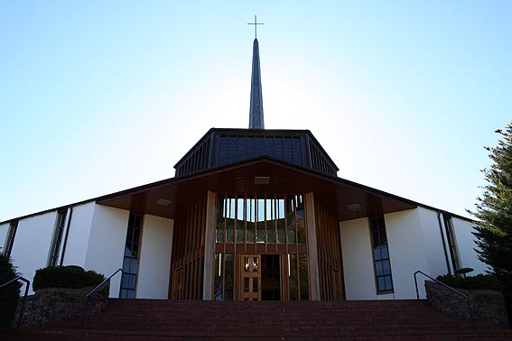
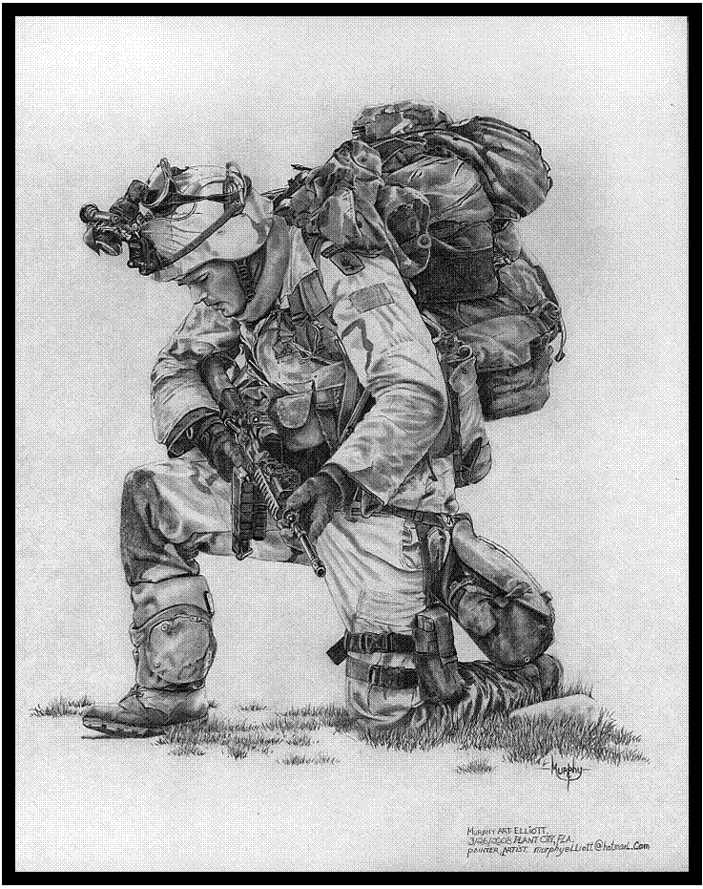

National Day of Prayer for Defence

28 March 2015

National Day of Prayer for Defence
Sponsored by Military Christian Fellowship of Australia
http://www.mcf-a.org.au/
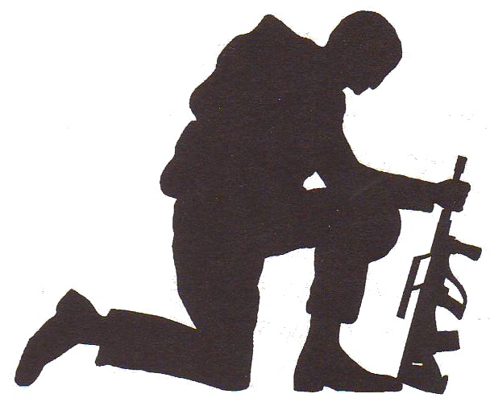

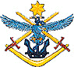

Contents
Welcome ……………………………… 3
The Lord’s Prayer ……………………………… 3
Order of Events ……………………………… 4
Scripture ……………………………… 4
Thanksgiving ……………………………… 5
Prayers ……………………………… 6

Prayer Group 1: ……………………………… 7
Defence Culture and
Training Settings

Prayer Group 2: ……………………………… 9
Deployed Personnel, Defence
Members and families

Prayer Group 3: ……………………………… 10
Senior Leadership, Chaplains
And Faith Under Fire Course

Prayer Group 4: ……………………………… 11
Defence Christian Military Ministries

Prayer for Defence Reconciliation……………….. 12
Proclamation about ADF based on Ezekiel 37 13

2
Welcome
Welcome to the National Day of Prayer for Defence. We appreciate your commitment in giving your time to pray for the Australian Defence Force in a challenging time, for Defence members, families, leaders, and government. We also need prayer to give us wisdom and strength to make the right decisions to guide our nation into the future. Defence Christian military ministry members as well as Chaplains and those who have a heart for Defence are joining with you today around Australia to be a part of this important activity. Jesus demonstrated a regular and passionate prayer life, sometimes publicly and sometimes alone. He also prayed at critical moments in his life. He gave a simple but powerful example of how to pray with The Lord’s Prayer (Luke 11:1).

THE LORD’S PRAYER
Our Father in heaven,
hallowed be your Name,
your kingdom come,
your will be done on earth, as in heaven.
Give us today our daily bread.
Forgive us our sins
as we forgive those who sin against us.
Save us from the time of trial
and deliver us from evil.
For the kingdom, the power and the glory are yours
now and forever,
Amen.

Order of Events (To be developed by regional contact)
Adjust the content of this booklet to suit your group. Either pray through the elements together or break up into small groups.

Songs
The facilitator may include songs if appropriate.
3
SCRIPTURES (selection of verses below or choose others)

2 Chronicles 7:14-15
If my people, who are called by my name, will humble themselves and pray and seek my face and turn from their wicked ways, then I will hear from heaven, and I will forgive their sin and will heal their land. ¹⁵ Now my eyes will be open and my ears attentive to the prayers offered in this place.

1 Timothy 2:1-4
I urge, then, first of all, that requests, prayers, intercession and thanksgiving be made for everyone-- for kings and all those in authority, that we may live peaceful and quiet lives in all godliness and holiness. This is good, and pleases God our Saviour, who wants all men to be saved and to come to a knowledge of the truth.

Psalm 20
May the Lord hear you in the day of trouble: the God of Jacob lift you up to safety. ²May he send you his help from the sanctuary: and be your strong support from Zion. ³ May he remember all your offerings: and accept with favour your burnt sacrifices, ⁴Grant you your heart's desire: and fulfil all your purposes. ⁵May we also rejoice in your victory and triumph in the name of our God: the Lord perform all your petitions. ⁶Now I know that the Lord will save his anointed: that he will answer him from his holy heaven with the victorious strength of his right hand. ⁷Some put their trust in chariots and some in horses: but we will trust in the name of the Lord our God. ⁸They are brought down and fallen: but we are made strong and stand upright. ⁹O Lord, save the king: and hear us when we call upon you.
4
THANKSGIVING

Almighty God,
in your wisdom you so ordered our earthly life
that we must walk by faith and not by sight:
give us such trust in your care, that in the face of all challenges
we may give proof of our faith by the courage of our lives;
through Jesus Christ our Lord. Amen.

- Thankyou for your Son Jesus Christ the Lord, for his sacrificial life.
- Thankyou for God’s great mercy upon our nation.
- Thankyou for raising righteous Godly people in positions of influence in the ADF, especially, for BRIG Fortune, as the Patron of Military Christian Fellowship.
- Thankyou for ADF chaplaincy and the wonderful work that they do as Christ’s ambassadors in the ADF.
- Thankyou that spiritual matters are valued by the ADF.
- Thankyou for the inception, launch and implementation of the ADF Faith Under Fire Course. Thankyou for lives changed and transformed.
- Thankyou for Defence Christians who are growing in discipleship and standing strong in their faith.
- Thankyou for the valour & courage of the troops in operations.
- Thankyou for the marriages and families of service personnel.
- Thankyou for the relationships between service men and women, whether junior or senior staff, that God has reconciled or brought in peace where it is needed.
- Thankyou for the guidance of the Holy Spirit in deepening faith and growing godly lives of integrity that multiply God’s grace.

5
PRAYERS

The SOLDIER’S Prayer
Almighty God, whose command is over all, and whose love never fails, let me be aware of your presence, and obedient to your will. Help me to accept my share of responsibility with a strong heart and cheerful mind. Make me considerate of those with whom I live and work, and faithful to the duties my country has entrusted to me. Let my uniform remind me daily of the traditions of the Service in which I serve. When I am inclined to doubt, strengthen my faith. When I am tempted to sin, help me to resist. When I fail, give me the courage to try again. Guide me with the light of your truth and keep before me the life and example of Jesus in whose name I pray. Amen.

The NAVAL Prayer
Eternal God, creator of the heavens and ruler of the raging seas, take under your powerful protection and bless all members of the Royal Australian Navy. Preserve them from the dangers of the sea and strengthen them so that they may faithfully serve our country. With the help of others who love freedom may they be able to ensure security for all those who lawfully travel the seven seas, and by their effort maintain for all people the possibility of serving you in peace and justice all through their lives. We ask this through Jesus Christ, our Lord. Amen.

The RAAF Prayer
O Lord, our God, who has given us dominion over earth, air, and sea. We ask you to be present with us who are called to serve our country in the Royal Australian Air Force. Give us courage, a steady nerve and ready mind. Sustain us in days of preparation in the daily routine servicing and weary waiting. Be with us in time of sudden peril and grant that under your mighty protection, we may be preserved in body, soul, and mind. We ask this through Jesus, Christ, our Lord. Amen.
6
Prayer Group 1:
defence Culture and Training Settings

Defence Culture
Defence has a strong culture that is based on Christian values. Some members have, however, not exercised their leadership positions to the standard that the ADF expects. As a result, there are a number of current and ex service personnel who have been impacted physically, emotionally and spiritually by their actions. A number of reviews have been put in place to improve certain elements of the ADF culture. Pray for Godly wisdom for our senior leaders as they implement the recommendations of these reviews.
Pathway to Change is Defence’s response to the cultural issues that have been raised. It provides a clear commitment to shape Defence's collective attitudes, systems and behaviours to improve capability and ensure the continued support of the Australian public.
- Pray for the operational phase of the Defence Abuse Response Taskforce.
- Pray for appropriate outcomes for complainants.
- Pray for the three unique programs that the Taskforce has developed: the Defence Abuse Restorative Engagement Program; the Defence Abuse Reparation Scheme; and the delivery of contracted counselling services around Australia under the Taskforce’s National Counselling Scheme.
- Pray for the effectiveness and efficiency of the delivery of key outcomes via the Taskforce developed individual project plans.
- Pray that the Defence Abuse Response Taskforce’s efforts to provide individually tailored and appropriate outcomes for victims of abuse will prove to be an important part of their recovery process.
- Pray that the ADF continues to use all available mechanisms to actively hold people who fail to live up to Defence values and expected behaviours to account.
7
Prayer Group 1:
defence Culture and Training Settings continued
- Pray for the three unique programs that the Taskforce has developed: the Defence Abuse Restorative Engagement Program; the Defence Abuse Reparation Scheme; and the delivery of contracted counselling services around Australia under the Taskforce’s National Counselling Scheme.
- Pray that the Restorative Engagement Program continues to enable individuals to participate in facilitated restorative conferences with senior Defence Representatives. Through this Program, victims have the opportunity to have their experiences of abuse personally heard, acknowledged and, where appropriate, responded to by a senior member of the ADF. Participation by senior ADF representatives is an important step in demonstrating, through action, the commitment of our senior leadership to acknowledging the unacceptable treatment and experiences of some people in the past. Importantly this program is exposing today’s and tomorrow’s senior ADF leaders to the pain and damage caused by abuse. You simply can not come away from one of these encounters without being effected.

Training Settings
There are many training settings across Defence: technical or initial entry settings - to officer and post graduate settings.

- Pray for the instructional staff.
- Pray for wisdom to deal with the difficult outcomes that sometimes occur.
- Pray for their family life relationships.
- Pray that Christian military ministries and chaplains operating with the training institutions will be successful in bringing the word of God to the trainees.
- Pray that the trainees will be open to hearing the gospel and acting on it
8

Prayer Group 2:

DEPLOYED PERSONNEL, Defence members

and families
- That ADF members will carry out their responsibilities well.
- Pray for the protection of deployed service men and women.
- Pray for the families of ADF personnel, especially those who are currently deployed.
- Pray for returned service men and women who are coping with physical, emotional and spiritual injuries.
- Pray for their well being, for healing and wholeness.
- Pray that service men and women will fulfil their God given purpose.

The Government has approved the deployment of approximately 1640 (total as at 2 Feb 2015, from website pdf dated 8 Oct 2014 ) Australian Defence Force personnel to 14 operations overseas and within Australia to protect Australia and its national interests. Of these, approximately 500 ADF members are actively protecting Australia's borders and offshore maritime interests.

Operation Location Personnel
Accordion Middle East Region 400
Aslan Sudan 25
Gateway South East Asia TBA
Manitou Middle East Region 270
Mazurka Egypt 25
Okra Iraq 600
Paladin Israel/Lebanon 13
Palate II Afghanistan 2
Render Safe Pacific Island Countries 2
Resolute Australian Maritime Interests 500
Slipper Afghanistan/Middle East 400
Solania South West Pacific TBA
Southern Indian Ocean Southern Indian Ocean 3
9
Prayer Group 3: SENIOR Leadership, Chaplains, and Faith Under Fire COURSE

Senior Leadership
Minister for Defence Secretary of Defence Chief of Defence Force
Kevin Andrews MP Dennis Richardson AO Air Chief Marshal
Mark Binskin AC
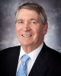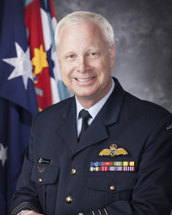
_________________________________________________________________________

Chief of Army Chief of Navy Chief of Air Force
LTGEN Vice Admiral AIRMSHL
David Morrison Tim Barrett Geoff Brown
AO AO, CSC, RAN AO CAF
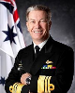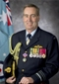
_________________________________________________________________________

Chaplains
The ADF regards attention to the spiritual needs of its members as a matter of the highest importance and is committed to providing them with the opportunity and facilities for the practice of their faith. ADF Chaplaincy is ministry without borders. Pray for ADF chaplains that they will be Christ’s ambassadors in the ADF and that they will be able to exercise the spiritual component of their responsibilities well.

ADF Faith Under Fire Course
Pray that Defence Christians will facilitate and lead this course across ADF bases and that service personnel will attend the course and seek for themselves who Jesus is and what they should do about matters of faith.
10
Prayer Group 4:
Defence CHRISTIAN Military Ministries
- Christian support groups for military wives/female partners.
- Pray for unity between the ministries.
- For Godly wisdom and leadership.
- For Christian Defence Members to support the ministries
- For Gods will to be done through the ministries.
- For resources to provide capacity to implement ministry plans.

Military Christian Fellowship
- Equipping, encouraging and supporting Military Christians to
build the Kingdom of God in the ADF.

Solid Rock Ministries
- Christian support groups for military wives/female partners.

Chaplains
- Provide religious ministry and pastoral care to service members and their families.

Everyman’s Welfare Services
- Offering Christian support to the Australian Defence Force Personnel, Service Veterans and Allies.

FOCUS Military Ministry
- Networking, equipping and inspiring personnel to make a difference for the Kingdom of God in the Defence Force.

Red Shield Defence Services
- Welfare & Morale support with a listening ear.
Practical and spiritual support through God's love.

Navigators Military Ministry
- To advance the Gospel of Jesus and His Kingdom into the nations through spiritual generations of labourers living and discipling among the lost.

Association for Christian Conference & Teaching Service
- Pray for replacements for Russell and Helen Bielenberg to continue this ministry;
- ACCTS trains military Christian leaders to form locally-led Military Christian Fellowships (MCFs). 11
PRAYER for defence reconciliation

Lord, we thank you that you have great plans and purposes for the Australian Defence Organisation.

We are sorry that there have been occasions where we as Defence members, past and present, may have not appropriately exercised our responsibilities and have caused physical, mental and spiritual injuries to Defence members. Additionally, our culture has been tolerant of some of these actions. These actions have served Defence poorly, hurting our people and damaging our reputation. We admit our shortfalls and seek your wisdom Lord Jesus and acknowledge that it is only through your atoning sacrifice at Calvary and the blood that you shed, that our sins can be forgiven.

We want to be in alignment with your will. We thank you that through taking hold of your victory at Calvary we can trust your word that you will purify us of from all unrighteousness as we have confessed our sin before you. We desire to learn your ways. By faith with your leading and guidance we will be able to deal with the past and move forward into your will for us. We thank you for the strength that comes from our Godly heritage and we desire to take on the values of your kingdom culture of right honor, respect and truth.

Lord, give our senior leadership your wisdom to implement changes to our culture that conform to your will, and give our Defence members the right attitude to change aspects of our culture that are not becoming to you and our professional Defence organisation. We commit our Defence organisation into your hands and pray that righteous men and women will lead it to fulfil the purposes and plans that you have for our Defence organisation and our nation.
In Jesus name. Amen

by LTCOL Jamie Van Heel (April 2012)
12
Proclamation about adf based on ezekiel 37

Australian Service men and women, hear the word of the Lord, in Jesus’ name. The sovereign Lord says to you, “I will make my breath enter you and you will come to life. As my son, Jesus, had victory over death and the grave, I will open your graves, shine my light to expose deception, deliver you from unbelief and captivities of the enemy. As you turn to me, you will know and love the truth that will set you free as you receive me Jesus as your saviour and redeemer. I will put my spirit into you, you will live, you will know me and that I am the Lord your GOD.” Then you will say, “Christ is my hope. I can do all things through Christ who strengthens me.” The Lord God almighty, the Captain of the hosts’ Armies would say to his people, “Submit whole heartedly to me, resist the devil and he will flee. Do not let your hearts be troubled. Trust the LORD your God and put your faith in me; love and worship me, meditate upon my word, praise God, and determine in your heart to obey me and to follow my ways. Thank me that I have called you. Stand up on your feet, enter into your inheritance and take your position to be a physical and spiritual army for my purposes. I have gone before you. The mandate that I have prepared for you as part of the great southlands of the holy spirit is to reach out to my covenant land and first covenant people Israel so that my name might be glorified through you and magnified throughout the whole earth.”

by LTCOL Jamie Van Heel and Mrs Hilary Moroney
(April 2014).

13

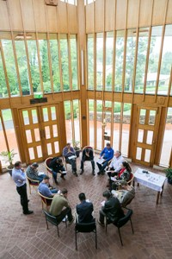

National Day of Prayer for Defence
Sponsored by Military Christian Fellowship of Australia
http://www.mcf-a.org.au/
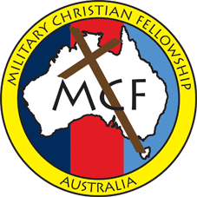

http://www.biblegateway.com/passage/?search=1%20Corinthians%202:7-16&version=CEV
http://www.biblegateway.com/passage/?search=Revelation%207:9-17&version=CEV
Copyright © 1995 by American Bible Society Contemporary English Version (CEV)
A Prayer Book For Australia, 1999, the Anglican Church of Australia, Broughton Books, Mulgrave, Vic, p. 591.
http://www.defence.gov.au/operations

